A closed-domain Question Answering System on COVID-19 for low-resource Indic languages
Shanjana Pulagala  CSE  IIIT Sri City  Andhra Pradesh, India  Email: shanjana.p19@iiits.in | Virri Anusha  CSE  IIIT Sri City  Andhra Pradesh, India  Email:  anusha.v19@iiits.in | Palam Bindu Bhargavi  CSE  IIIT Sri City  Andhra Pradesh, India  Email:  bindubhargavi.p19@iiits.in | Dasari Charan Sai  CSE  IIIT Sri City  Andhra Pradesh, India  Email: charansai.d19@iiits.in

Abstract— Over the last few decades, Question Answering emerged as an interesting field of information in Computer Science domain. This system is comprised of three key modules namely— Data Preparation, Query Processing and Answer Processing. Since COVID-19 came into existence, there is an increasing rate of variability in a gradual fashion. Browsing the exact accurate answer for a particular question across various websites is tedious and inconvenient. Judging the trustworthiness of answers is also a challenge. The following paper is an endeavour to overview the entire Question Answering system simultaneously guiding people in obtaining reliable answers. We succeeded in our attempt to assist low-resource language users by designing the Question Answering system in both English and low-resource natural Indic languages.

Introduction
With the prevailing pandemic across the globe, there is a lot of uncertainty growing day-by-day. The very outbreak of Corona virus pandemic rose to a global health chaos that is deeply impacting the way we perceive our world and our everyday lives.
The requirement to query information content in a variety of formats, including structured and unstructured data such as natural language text, semi-structured Web pages, structured RDF data on the semantic Web, etc., has grown in importance. To meet this demand, Question Answering Systems (QAS) are required. The goal of the Question Answering System is to make the web more human-friendly by reducing the need to manually filter through a large number of search results to get the proper answer to a query.
In Natural Language Processing (NLP), Question Answering (QA) is a significant domain with a broad range of applicability resulting in diverse applications like information extraction and its retrieval. The sole intention of a QA system is to answer a given query by generating it automatically.
The QA system formulates the questions in natural languages and also handles answers in natural languages. In order to carry out the process, QA

system replies back the closest answer to the asked question in natural language with the use of pre-structured database and set of natural languages records. In a nutshell, unlike search engines searching full documents, this system presents only the requested information.
Thus, to guide people in search of accurate answers, we here are contributing to a better solution in form of a closed-domain QA system exclusively designed on COVID-19 and its concerns. We aim to improve precision of answers to the questions raised by people about the virus and its consequences.
  - Motivation
Most of the existing works focus on retrieving answers in widely used and resource-rich languages, for example, universally accepted language—English.
For multilingual information access, creating a benchmark setting for multilingual QA incorporating Indian languages will be advantageous. To the best of our knowledge, this is the first attempt in this way.
Most of the Indic languages are resource-scarce. Therefore, we chose to provide this query-answering platform in both English and low-resource Indic languages.

State of the Artwork
A lot of work and research is accomplished by innumerable people in the domains of QA using NLP techniques round the globe. Some of them had also focused on developing in Indic languages. This eminent growth of progress encourages this research. Hence, we discussed the supporting work accordingly.
COBERT is a retriever-reader dual algorithmic system proposed by Jafar A. Alzubi and group [1] that answers complex queries by searching a document of 59K corona virus-related literature made available through the Coronavirus Open Research Dataset Challenge, with an Exact Match (EM)/F1 score of 80.6/87.3. However, the proposed model only captures context-sensitive characteristics from the resulting embedding and is pre-trained on a closed domain of COVID-19 literature, which is only available in English.
A Multi-domain Multi-lingual Question-Answering Framework for English and Hindi was created by Deepak Gupta and his colleagues [2]. In order to categorize an input question into coarse and finer categories based on the predicted answer, a deep learning-based model is constructed. Similarity computation and subsequent ranking are used to retrieve answers. There are 5, 495 question-answer pairs with questions and responses in both English and Hindi. The questions and answers might be factoids or brief descriptive sorts. The accuracy of the question categorization model is 90.12%. However, the QA pairs are limited, they only utilize the Hindi language and the types of questions are limited.
The notable deep-learning-based medical textual QA efforts were thoroughly assessed by Emmanuel Mutabazi and the group [3]. They began with a brief introduction to QAS, including the duties, kinds, and representations of medical QAS. Then, obtained an F1 Score of 88.5% on the MedQuAD (Medical Question Answering Dataset). The system's flaws include inability to find relevant and trustworthy answers and delay in delivering appropriate answers by the existing medical search engines. Also, the availability of large medical datasets is scarce.
Dennis Diefenbach and his colleagues [4] suggested a method for converting natural language inquiries into SPARQL queries. It can query many KBs in various languages at the same time and can be simply adapted to additional KBs and languages. The impact of our technique is seen in our assessment utilizing five well-known and huge KBs: Wikidata, DBpedia, MusicBrainz, DBLP, and Freebase, as well as five languages: English, German, French, Italian, and Spanish. But, the technique is not parallelizable, which means that when querying many KBs, acceptable response times will not be obtained.
Arjit Das and group [5] used unsupervised statistical approaches to construct a Bengali factoid question answering system. The system accepts the human's inquiries and then searches a multi-domain repository for all possible responses. For the TDIL corpus, accuracy and F1 score are determined as 97.64 percent and 98.5 percent, respectively, and for translated SQuAD, 97.16 percent and 98.51 percent. However, for narrative or descriptive replies, the system fails to return the solution when the answer must be generated by producing new text from the facts, and when the facts of the answers are not included in the text corpus, the system fails to retrieve the precise answer.
Arantxa Otegi and team [6] have released ElkarHizketak, a low-resource conversational question-answering dataset in Basque that was built in a difficult environment: crowd workers were unavailable, and Wikipedia was smaller. It is the first non-English CQA dataset that is open to the public. With the use of a cross-lingual transfer, the best results are produced with limited amounts of native data, with a quality equivalent to that of English. However, discourse models are not transferable between languages.
Jonathan H. Clark and his colleagues [7] created TYDI QA, a question-answer dataset with 204K question-answer pairings that covers 11 typologically different languages. The model takes a query and the text of a Wikipedia page and generates a response using either a Passage Selection Task or a Minimal Answer Span Task. However, the methodology does not allow for transfer learning in both accessible and unavailable languages.
Using question-answering (QA), Daniel Deutsch and his colleagues [8] presented a measure to assess the content quality of a summary. These QA-based approaches explicitly quantify the information overlap between a summary and a reference, which distinguishes them from text overlap measures. In addition, he introduced the QAEval metric, which beats other metrics. However, QAEval's reliance on predicate-argument relations throughout each component of the measure limits it. The question generation model can only produce questions that reason about predicates' arguments; it can't generate more abstract inquiries.
CORA, a unified multilingual many-to-many open QA model that retrieves multilingual passages in many different languages and provides responses in target languages, was presented by Akari Asai and group [9] to fulfill the information demands of numerous non-English speakers. Experiments revealed two multilingual open QA datasets including 28 languages, 26 of which CORA outperformed competing models by up to 23 F1 points. Nonetheless, the retrieval component has trouble finding relevant sections for queries in certain languages that aren't yet available. CORA occasionally fails to create an answer in the target language, according to the research.
Gokul Karthik Kumar and his colleagues [10] used translation and transliteration into other languages to enhance QA samples in the target language, then used the enriched data to fine-tune an mBERT-based QA model that was previously pre-trained in English. Experiments on the Google ChAII dataset reveal that fine-tuning the mBERT model with translations from the same language family improves question-answering performance, whereas cross-language families reduce performance. Because the size of the Google ChaII dataset is inadequate to fine-tune a 177M parameter model, only a modest improvement in QA performance is seen.

3. Proposed System
When a natural language question is given, a closed-domain question answering (QA) system is designed exclusively for COVID-19 related questions. Here, we aim to develop our mentioned Q&A system in both English and Telugu languages.
- Given, a natural language question ‘Q’ (factoid or short descriptive) in either language, English or Telugu.

- The closed-domain Question answering (QA) system should return the answer ‘A’ for the given question Q from the comparable English structured dataset.

- The returned answer A should be in the same language as the question Q.
3.1 Main Modules
Our proposed QA system comprises of three main N
    - Data Preparation
    - Query Processing
3.1.3 Answer Processing
Each module is discussed in detail below.
    - Data Preparation
Data preparation is the process of operating raw data gathered from various data sources into a collection for easier readability and accurate analysis.
The dataset we used in our system is COVID QA which is in the format of Stanford Question Answering Dataset- SQuAD. We carried out the procedure through the following steps:
Step 1: Data Collection
The data is collected from the COVID QA dataset and loaded in a virtual location so that it can be accessed for the later process.

Step 2: Data Retrieval
The data loaded in the virtual location is now retrieved into a data-frame.

Step 3: Data Importing
Training dataset and Validation dataset are created from the data-frame obtained in Step 2.
    - Query Processing

The goal of Query processing is to carry out the extraction of the important keywords from the question. For a given input query in a natural language, the following procedure is adopted.
Step 1: Identification of the Query language
Firstly, the language of the input query is identified and translated into English if the query is in non-English language, here, Telugu.
Step 2: Query Analysis
We then analyze the query by changing all the alphabets of it to lower case and removing punctuation in it.
Step 3: Query Classification
On the basis of the question type – What, When, Where, Which, Who, How, etc., the query is sorted.
To implement this procedure, we have used the following NLP techniques.
- Parts of Speech – POS Tagging

To begin with, all the features from the sentence words are extracted which are used to predict the POS.
The dataset is split into Training and Testing datasets. The tagger is then trained with the extracted features for obtaining accuracy.

- Addition of required entity type

In order to insert the entity type for the input query, all the question types are examined carefully. Below is a list of labels for some of the question types.

QUESTION TYPE | ENTITY  TYPE
How | Quantity
What | Description
When | Date and Time
Where | Location
Which | Location
Who | Organization

- Dependency Parsing

At first, the query is checked for projective dependency tree i.e., the sentence should not possess any intersection of dependencies. Then, the model is trained with features and labels. Later the sentence is parsed with the acquired trained model. Correctness of the model is obtained. Dataset of this model is evaluated for results.

- Synonym Extraction

To aid the precision of output- answer to be delivered to the user, synonyms are extracted for each word in the query sentence.

- Named Entity Recognition - NER

NER is implemented to detect the entity and characterize important information of the text in the sentence. All the detected entities are categorized into pre-determined groups.
Some of them are listed below:

ENTITY LABEL | WORDS
COVID | Corona virus  Sars-Cov19  COVID19
DIST | Social distance  lockdown  work from home
DIT | (hand) sanitizer/soap  hygiene  wipe
PPE | mask/facemask(s)/face shield  n95(s)/kn95  cloth/gown
SYM | death  flu/influenza  cough/coughed
TEST | cases  (antibody) test  test results (positive/negative)

Step 4: Query Reformulation

The query is reformulated after extracting the key words from the query.

    - Answer Processing

Once the query is processed completely, the answer processing is initiated to get the appropriate answer as the output.
The following steps are discussed now.

Step 1: Identifying the requested Answer

All the relevant sentences are filtered based on the query using Semantic Textual Similarity technique.

Initially, the context of dataset is cleaned and later encoded to get the embedding for both the sentences and the query. The resulted Cosine Similarity scores of the context embeddings appear against the query.

Step 2: Answer Extraction

On the basis of accuracy and precision, the required answer is extracted from the refined ones.

This contains two sections-

- Dependency Parsing

The top similarity scores of contexts are taken into consideration for obtaining refined sentences. Dependency parsing is now applied on these sentences to get root-filtered (query sentence root and answer sentence root are equal) and noun-filtered (answer sentences having dependency label ‘nsubj’ and ‘dobj’) lists. The lists are further refined based on the synonyms of the query words.

- Obtaining the exact answer

From the root filtered sentences the exact accurate answer is extracted. Further the answer text is appended and returned.

Step 3: Answer Translation

The resulted language is translated as per the given input language— Telugu.
4. Results
Sample input we used is a query in a natural Indic language— Telugu:
కరోనా వైరస్ మొదటిసారిగా ఏ దేశంలో గమనించబడింది?
Translation: In which country was the corona virus first detected?
The obtained results for our modules are mentioned below:
4.1.1 Data Preparation
Below is the resulted data-frame of the data we collected.
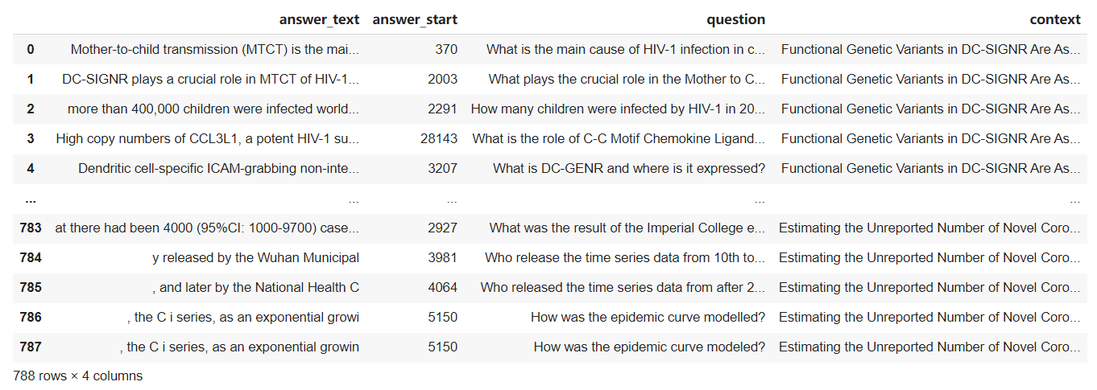
Fig 4.1.1a: Data-frame
4.2 Query Processing
We listed the results for all the NLP methods used in Query Classification (3.1.2- Step 3).
4.2.1 POS Tagging
We used tags from Penn treebank to implement POS tagging.
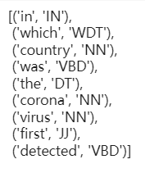
Fig 4.2.1a: POS Tags
4.2.2 Adding required entity type
The input query we used had ‘Which’ as the question type. Hence, the entity type is ‘LOC’ i.e., Location.
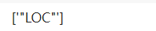
Fig 4.2.2a: Entity Type
4.2.3 Dependency Parsing
The dependency parsed tree is displayed for all the obtained tokens of the query.
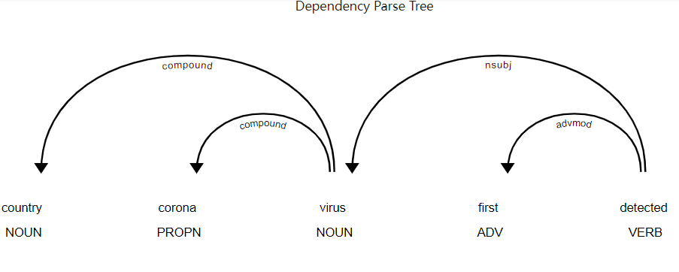
Fig 4.2.3a: Dependency parsed Tree
4.2.4 Synonym Extraction
The synonyms of each word in the query are drawn into a single place and displayed.
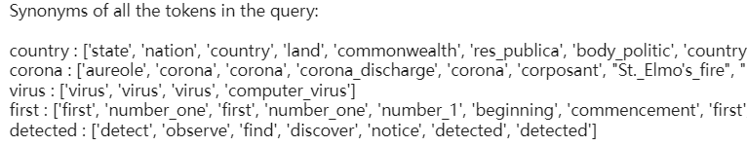
Fig 4.2.4a: Synonyms for the query words

4.2.5 Named Entity Recognition
Entity labels are assigned to each word in the query sentence.
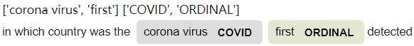
Fig 4.2.5a: Named entity recognition tags

4.3 Answer Processing
The results of certain steps of this module are mentioned below:
4.3.1 Identifying the requested Answer
The Cosine Similarity scores for each context sentence embedding is shown below:
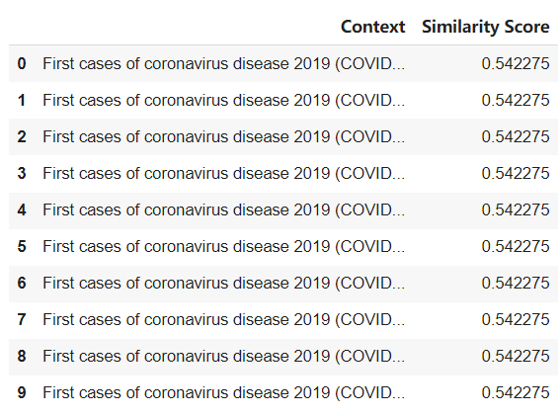
Fig 4.3.1a: Cosine Similarity scores
4.4 Final Result
For the input query we have taken, the answer we obtained after completion of Answer Processing is చైనా - Translation: China.

Final Output is shown below:
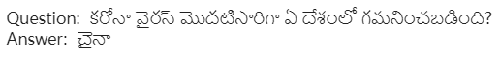Fig 4.4a: Output of QA system for the sample query

5. Conclusion & Future Work
In our proposed model, we designed and developed a closed-domain QA system on COVID-19 and its related topics. We also considered the thought of applying Indic languages to our work and hence decided to bring an Indic language, Telugu into force. Accordingly, we worked on creating a closed-domain QA system exclusively on COVID-19 in both English and Telugu natural languages.
We are interested in continuing our work further by expanding the boundaries and improving the current progress. We would like to increase the quantity of base data by collecting and summing up data from several sources. We mainly aim to escalate accuracy and are willing to extend our system to other natural languages as well. To enhance the user experience, we desire to build a user-friendly interface for this system also offering an option to select the language of their choice.
References
- Alzubi, J. A., Jain, R., Singh, A., Parwekar, P., & Gupta, M. (2021). COBERT: COVID-19 question answering system using BERT. Arabian Journal for Science and Engineering, 1-11.
- Gupta, D., Kumari, S., Ekbal, A., & Bhattacharyya, P. (2018, May). MMQA: A multi-domain multi-lingual question-answering framework for English and Hindi. In Proceedings of the Eleventh International Conference on Language Resources and Evaluation (LREC 2018).
- Mutabazi, E., Ni, J., Tang, G., & Cao, W. (2021). A review on medical textual question answering systems based on deep learning approaches. Applied Sciences, 11(12), 5456.
- Diefenbach, D., Both, A., Singh, K., & Maret, P. (2020). Towards a question answering system over the semantic web. Semantic Web, 11(3), 421-439.
- Das, A., Mandal, J., Danial, Z., Pal, A. R., & Saha, D. (2022). An improvement of Bengali factoid question answering system using unsupervised statistical methods. Sādhanā, 47(1), 1-14.
- Otegi, A., Agirre, A., Campos, J. A., Soroa, A., & Agirre, E. (2020, May). Conversational question answering in low resource scenarios: A dataset and case study for basque. In Proceedings of The 12th Language Resources and Evaluation Conference (pp. 436-442).
- Clark, J. H., Choi, E., Collins, M., Garrette, D., Kwiatkowski, T., Nikolaev, V., & Palomaki, J. (2020). TyDi QA: A benchmark for information-seeking question answering in typologically diverse languages. Transactions of the Association for Computational Linguistics, 8, 454-470.
- Deutsch, D., Bedrax-Weiss, T., & Roth, D. (2021). Towards question-answering as an automatic metric for evaluating the content quality of a summary. Transactions of the Association for Computational Linguistics, 9, 774-789.
- Asai, A., Yu, X., Kasai, J., & Hajishirzi, H. (2021). One question answering model for many languages with cross-lingual dense passage retrieval. Advances in Neural Information Processing Systems, 34.
- Kumar, G. K., Gehlot, A. S., Mullappilly, S. S., & Nandakumar, K. (2022). MuCoT: Multilingual Contrastive Training for Question-Answering in Low-resource Languages. arXiv preprint arXiv:2204.05814.
- Esteva, A., Kale, A., Paulus, R., Hashimoto, K., Yin, W., Radev, D., & Socher, R. (2020). Co-search: Covid-19 information retrieval with semantic search, question answering, and abstractive summarization. arXiv preprint arXiv:2006.09595.
- Jha, B. K., Akana, C. M. V. S., & Anand, R. (2021, April). Question Answering System with Indic multilingual-BERT. In 2021 5th International Conference on Computing Methodologies and Communication (ICCMC) (pp. 1631-1638). IEEE.
- Lende, S. P., & Raghuwanshi, M. M. (2016, February). Question answering system on education acts using NLP techniques. In 2016 world conference on futuristic trends in research and innovation for social welfare (Startup Conclave) (pp. 1-6). IEEE.
- Mattila, M., & Dahanayke, A. (2020, October). Systematic Literature Review of Question Answering Systems. In International Conference on Reliability and Statistics in Transportation and Communication (pp. 54-62). Springer, Cham.
- Rogers, A., Gardner, M., & Augenstein, I. (2021). Qa dataset explosion: A taxonomy of nlp resources for question answering and reading comprehension. arXiv preprint arXiv:2107.12708.
- Su, D., Xu, Y., Yu, T., Siddique, F. B., Barezi, E. J., & Fung, P. (2020). CAiRE-COVID: a question answering and query-focused multi-document summarization system for covid-19 scholarly information management. arXiv preprint arXiv:2005.03975.
- Sun, Y., Cai, Y., Shen, Y., Zhang, Q., Feng, X., Yin, M., & Li, D. (2021, October). The COVID-19 Question Answering System Based on Knowledge Graph. In 2021 IEEE/ACIS 20th International Fall Conference on Computer and Information Science (ICIS Fall) (pp. 215-220). IEEE.
- Vargas-Vera, M., & Lytras, M. D. (2010). Aqua: A closed-domain question answering system. Information systems management, 27(3), 217-225.

